HW5 Mohsen Nabian

**Question 1**

1. Plan 1

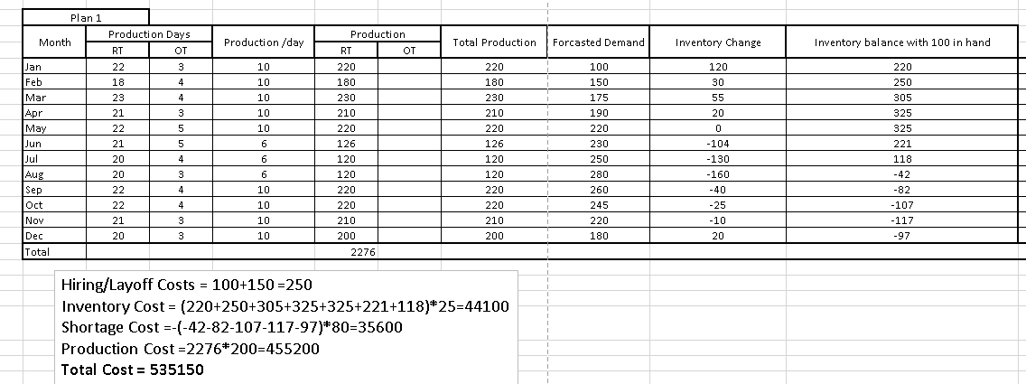

1. Plan 2

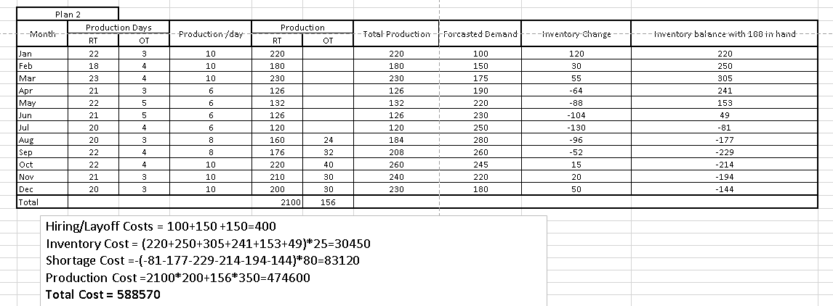

1. Plan 3

